March 20, 2020

Dhalla, Aashish

UFID: 7607-2356

Dear Aashish:

Congratulations! Your academic record of achievement within your undergraduate degree program, as well as your other accomplishments, is to be commended. In view of your outstanding credentials, you have been selected to receive a University of Florida, Herbert Wertheim College of Engineering ***Achievement Award Scholarship for New Engineering Graduate Students***. This offer includes a partial tuition waiver of $1,500 a semester for up to three semesters (minimum of nine hours enrolled per semester). The current out-of-state tuition and fees are $1,255 per graduate credit hour. The three semesters must be used within the first two years of enrollment. It is noted that no other University support (e.g., assistantship, fellowship, scholarship) is permitted while serving as an Achievement Awardee, although you may transition to such alternate support if funding becomes available.

The ***Achievement Award Scholarship for New Engineering Graduate Students*** is offered to incoming graduate students to convey our enthusiasm in attracting you to the University of Florida and our commitment to supporting your professional development. We hope this partial tuition waiver will make the cost of your education more affordable. The Achievement Award Scholarship represents a savings of $4,500 during your Master’s degree program. The academic year officially **begins August 16, 2020**.

We are very pleased to extend this offer and hope that you will agree to join UF Department of Computer & Information Science & Engineering. We believe that you will find that the University of Florida offers a stimulating, creative climate for graduate studies.

Please confirm your acceptance directly to Kristina Sapp at klsapp@ufl.edu via email and return the signed letter of offer at your earliest convenience but no later than **May 1, 2020**. If you have any questions, please do not hesitate to contact us.

Congratulations on your award and we look forward to seeing you in the Fall.

Best wishes,

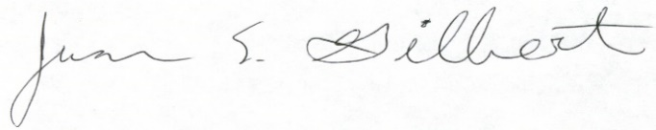 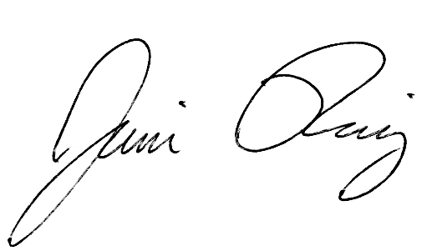

Dr. Juan Gilbert Dr. Jaime Ruiz

Professor and Chair Graduate Coordinator

***Requirements:***

* You will be required to maintain minimum enrollment as required by your visa.
* You must maintain satisfactory progress toward your degree with a 3.0 GPA in both your overall and major area of study (as well as in your minor areaif a minor is declared).
* Note that this appointment between you, the appointee, and the University of Florida is subject to the constitution and laws of the State of Florida, the rules of the Florida Board of Governors and the University of Florida, Board of Trustees, and the Collective Bargaining Agreement.
* Under the Immigration Reform and Control Act of 1986, the University of Florida is required to verify the identity and work authorization of all new employees. As a federal contractor, the University of Florida also participates in E-Verify, the federal on-line verification system.
* If you do not confirm that you will attend and accept the Achievement Award by **May 1**, 2020 the offer is rescinded.

**Accept/Decline Award Offer:**

I, Aashish Dhalla, 76072356  
 (print first name and last name) UFID (8 digit number)  
  
have read this letter and *accept* the Achievement Award Scholarshipand its requirements offered to me by the University of Florida.

I, _________________________________________, __________________________   
 (print first name and last name) UFID (8 digit number)  
  
have read this letter and *decline* the Achievement Award Scholarshipand its requirements offered to me by the University of Florida.

23-March-2020

Signature of Appointee Date of Acceptance/Decline